HEV Requirements

Revision 2.0

March 12, 2013

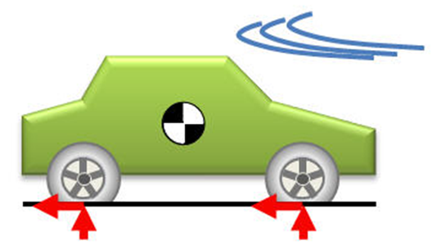

### Overall System Requirements

The following requirements apply to the HEV   
Dimensions:

* 1. Curb Weight: 1325 kg
  2. Length 4450 mm
  3. Width 1725 mm
  4. Height 1490 mm

Performance

* 1. Total Range 870 km
  2. Electric Range 18 km

### Engine System Requirements

The following requirements apply to the functionality of this module.

ICE

* 1. Power 57 kW @5000 RPM
  2. Min Speed 1000 rpm
  3. Max Speed 4500 rpm
  4. Torque 115 Nm @ 4200 RPM

…

### Fuel Consumption

The following requirements apply to the fuel consumption:  
  
 Regular Gas

* 1. City 51 MPG
  2. Highway 49 MPG
  3. Combined 50 MPG

Elec + Gas

* 1. Combined 95 MPG - e

### Speed Controller Module Requirements

The following requirements apply to the Speed Controller module.

* 1. The controller module will implement at a minimum proportional and integral control.
  2. Upon a change of angle, the system must be within 5% of the final value within 0.1 seconds (Settling Time).
  3. Upon a change of 10% the system must achieve 10% of the final value within 0.7 seconds

### Current Controller Module Requirements

The following requirements apply to the Current Controller module.

* 1. The current must remain within 1% of the command value.
  2. The current may not exceed XXX amperes.